Prometheus Grafana
Friday, May 31, 2024
12:57 PM

Installing Prometheus Grafana:
--------------------------------------------
- AWS Account: lz-dev
- EKS Cluster: sbx-eks-cluster
- Prometheus Grafana Installation Document:
  - https://github.com/jfrog/log-analytics-prometheus

Prometheus Grafana Prod Settings:
------------------------------------------------
https://grafana.pb.lz.us-cert.gov/login

Prod Grafana username: admin
Prod Grafana password: ~uKmpSC/jTG`7F&};|ft

Prometheus Grafana Dev Settings:
------------------------------------------------
https://grafana.sbx.lz.us-cert.gov/login

Default SBX Grafana username: admin
Default SBX Grafana password: prom-operator

Adding Prometheus Grafana Helm Chart:
---------------------------------------------------------
khaled.elsayed at ~/Documents/Repos/Helm/Prometheus-Grafana/helm ❯ helm repo add prometheus-community https://prometheus-community.github.io/helm-charts
"prometheus-community" has been added to your repositories

khaled.elsayed at ~/Documents/Repos/Helm/Prometheus-Grafana/helm ❯ helm repo update
Hang tight while we grab the latest from your chart repositories...
...Successfully got an update from the "sonarqube" chart repository
...Successfully got an update from the "docker-selenium" chart repository
...Successfully got an update from the "grafana" chart repository
...Successfully got an update from the "prometheus-community" chart repository
...Successfully got an update from the "cloudbees" chart repository
...Successfully got an update from the "jfrog" chart repository
Update Complete. ⎈Happy Helming!⎈

Search for the Latest Helm Version for Prometheus Grafana:
-----------------------------------------------------------------------------------
khaled.elsayed at ~/Documents/Repos/Helm/Prometheus-Grafana/helm ❯ helm search repo kube-prometheus-stack --versions
NAME CHART VERSION APP VERSION DESCRIPTION
prometheus-community/kube-prometheus-stack 59.0.0 v0.74.0 kube-prometheus-stack collects Kubernetes manif...
prometheus-community/kube-prometheus-stack 58.7.2 v0.73.2 kube-prometheus-stack collects Kubernetes manif...
prometheus-community/kube-prometheus-stack 58.7.1 v0.73.2 kube-prometheus-stack collects Kubernetes manif...

OR

khaled.elsayed at ~/Documents/Repos/Helm/Prometheus-Grafana/helm ❯ helm search repo prometheus-community/kube-prometheus-stack --versions
NAME CHART VERSION APP VERSION DESCRIPTION
prometheus-community/kube-prometheus-stack 59.0.0 v0.74.0 kube-prometheus-stack collects Kubernetes manif...
prometheus-community/kube-prometheus-stack 58.7.2 v0.73.2 kube-prometheus-stack collects Kubernetes manif...
prometheus-community/kube-prometheus-stack 58.7.1 v0.73.2 kube-prometheus-stack collects Kubernetes manif...

Pulling a Local Copy of Prometheus Grafana Helm Chart:
-----------------------------------------------------------------------------
khaled.elsayed at ~/Documents/Repos/Helm/Prometheus-Grafana/helm ❯ helm pull prometheus-community/kube-prometheus-stack

khaled.elsayed at ~/Documents/Repos/Helm/Prometheus-Grafana/helm ❯ helm upgrade --install "prometheus" prometheus-community/kube-prometheus-stack -n artifactory-ha
Release "prometheus" does not exist. Installing it now.
NAME: prometheus
LAST DEPLOYED: Thu May 30 17:00:38 2024
NAMESPACE: artifactory-ha
STATUS: deployed
REVISION: 1
NOTES:
kube-prometheus-stack has been installed. Check its status by running:
kubectl --namespace artifactory-ha get pods -l "release=prometheus"

Visit https://github.com/prometheus-operator/kube-prometheus for instructions on how to create & configure Alertmanager and Prometheus instances using the Operator.

Use the helm template command to test your configuration and generate a output.yaml file before actual deployment to EKS:
-----------------------------------------------------------------------------------------------------------------------------------------------------------------------------
khaled.elsayed at ~/Documents/Repos/Helm/Prometheus-Grafana/helm ❯ helm template grafana-prometheus prometheus-community/kube-prometheus-stack -n grafana-prometheus -f ../grafana.yaml > output.yaml

khaled.elsayed at ~/Documents/Repos/Helm/Prometheus-Grafana/helm ❯ ls -l
total 1136
drwxr-xr-x 4 workspaces\khaled.elsayed workspaces\domain users 4096 May 31 12:38 kube-prometheus-stack
-rw-r--r-- 1 workspaces\khaled.elsayed workspaces\domain users 513548 May 31 12:38 kube-prometheus-stack-59.0.0.tgz
-rw-r--r-- 1 workspaces\khaled.elsayed workspaces\domain users 639956 May 31 12:53 output.yaml

khaled.elsayed at ~/Documents/Repos/Helm/Prometheus-Grafana/helm ❯ cat output.yaml

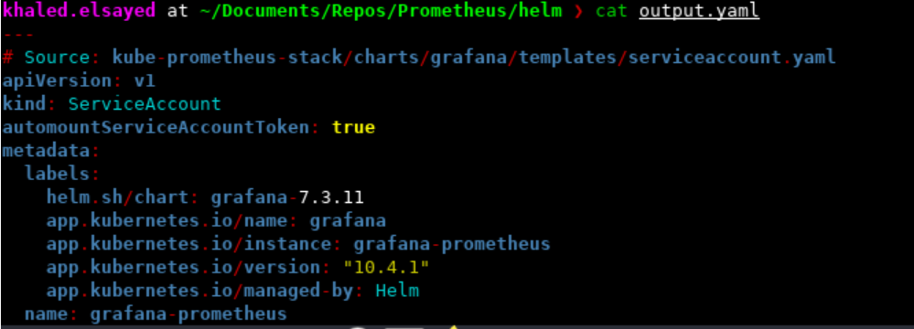

Configure Loki in the Dev environment:
-------------------------------------------------------
Go to Connections --> Data Sources

URL: http://loki.artifactory-ha:3100

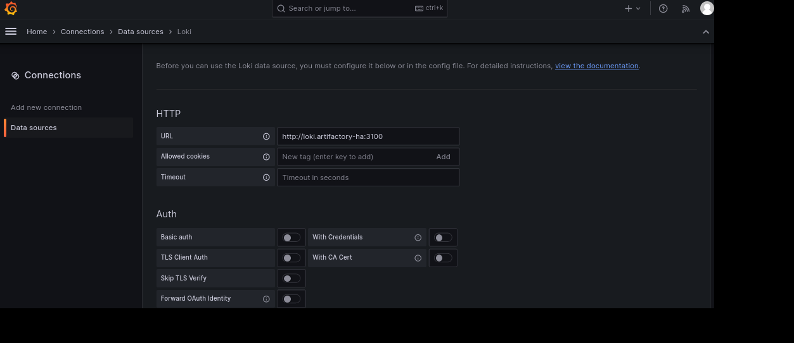

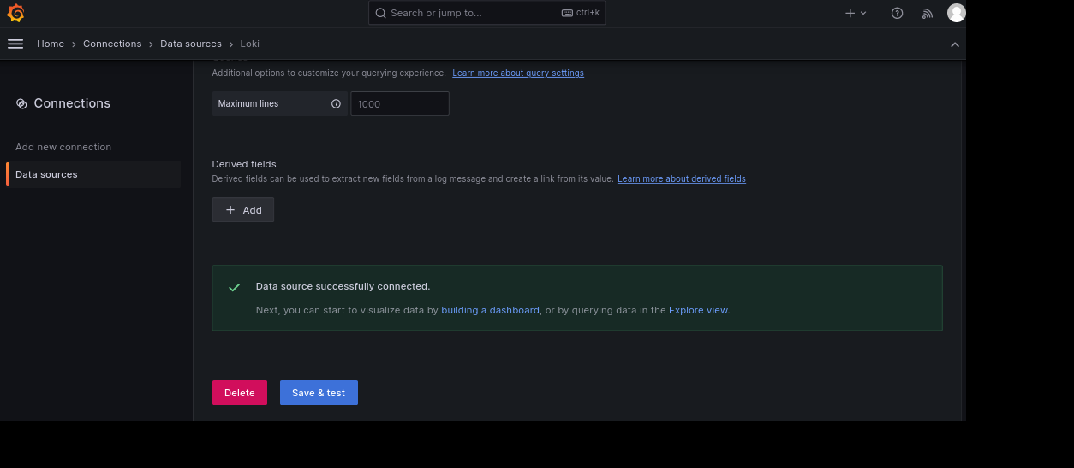

Grafana Configured Data Sources:
-----------------------------------------------

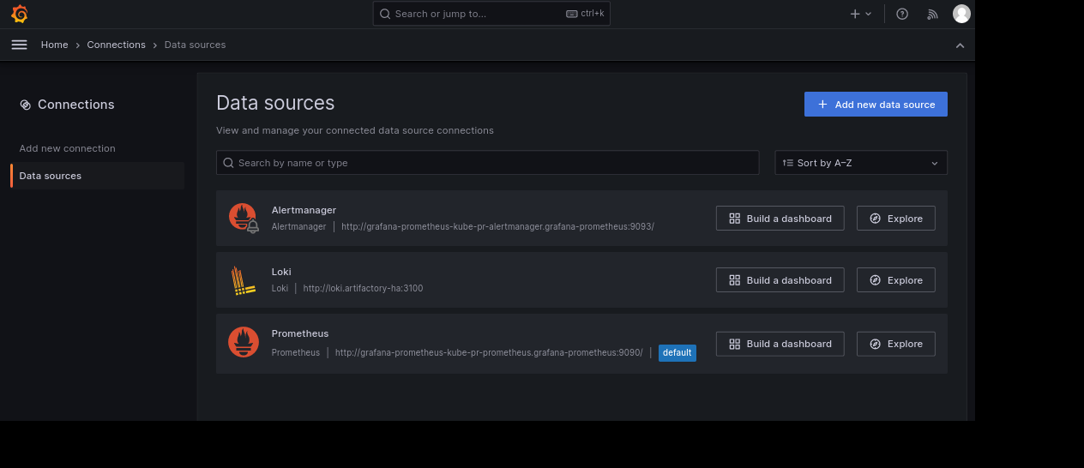

Setup Grafana Dashboards for Cloudbees Metrics:
---------------------------------------------------------------------

Run helm list command to find out the release name which is grafana-prometheus

khaled.fouad ~/Documents/Repos/Scripts-Logs/Kubernetes-Grafana-Config ❯ helm list -n grafana-prometheus
NAME NAMESPACE REVISION UPDATED STATUS CHART APP VERSION
grafana-prometheus grafana-prometheus 1 2023-04-27 20:46:21.987293411 +0000 UTC deployed kube-prometheus-stack-45.21.0 v0.63.0

khaled.fouad ~/Documents/Repos/Scripts-Logs/Kubernetes-Grafana-Config ❯ kubectl get prometheus -A
NAMESPACE NAME VERSION DESIRED READY RECONCILED AVAILABLE AGE
grafana-prometheus grafana-prometheus-kube-pr-prometheus v2.42.0 1 1 True True 2y23d

Run kubectl get pods command to find out the release name which is grafana-prometheus

khaled.fouad ~/Documents/Repos/Scripts-Logs/Kubernetes-Grafana-Config ❯ kubectl get pods -n grafana-prometheus --show-labels
NAME READY STATUS RESTARTS AGE LABELS
grafana-prometheus-kube-pr-operator-8568c465f9-rltqt 1/1 Running 0 53d app.kubernetes.io/instance=grafana-prometheus,app.kubernetes.io/managed-by=Helm,app.kubernetes.io/part-of=kube-prometheus-stack,app.kubernetes.io/version=45.21.0,app=kube-prometheus-stack-operator,chart=kube-prometheus-stack-45.21.0,heritage=Helm,pod-template-hash=8568c465f9,release=grafana-prometheus
grafana-prometheus-kube-state-metrics-5d4bbfcfd4-nvspx 1/1 Running 0 6d16h app.kubernetes.io/component=metrics,app.kubernetes.io/instance=grafana-prometheus,app.kubernetes.io/managed-by=Helm,app.kubernetes.io/name=kube-state-metrics,app.kubernetes.io/part-of=kube-state-metrics,app.kubernetes.io/version=2.8.2,helm.sh/chart=kube-state-metrics-5.5.0,pod-template-hash=5d4bbfcfd4,release=grafana-prometheus
grafana-prometheus-prometheus-node-exporter-6zqbc 1/1 Running 0 6d16h app.kubernetes.io/component=metrics,app.kubernetes.io/instance=grafana-prometheus,app.kubernetes.io/managed-by=Helm,app.kubernetes.io/name=prometheus-node-exporter,app.kubernetes.io/part-of=prometheus-node-exporter,app.kubernetes.io/version=1.5.0,controller-revision-hash=776f5bfdb4,helm.sh/chart=prometheus-node-exporter-4.16.0,jobLabel=node-exporter,pod-template-generation=1,release=grafana-prometheus

Deploy aws-cli pod in grafana-prometheus namespace:
----------------------------------------------------------------------------
We deploy the aws-cli pod in order to be able to do curl commands in grafana-promethus namespace.
I get the AWS_Access_Key & AWS_Secret_Access_Key from AWS Console as EKS-Admin-Role.

khaled.fouad ~ ❯ kubectl apply -f aws-cli.yaml

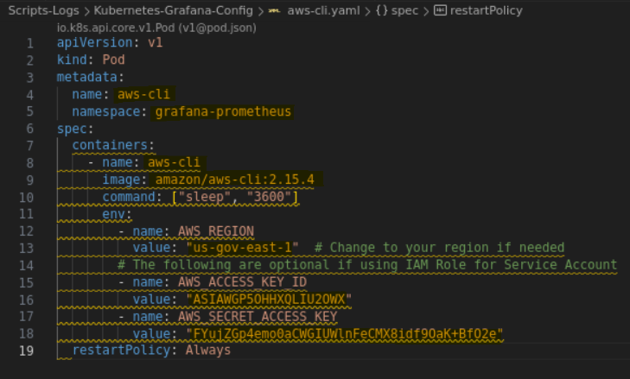

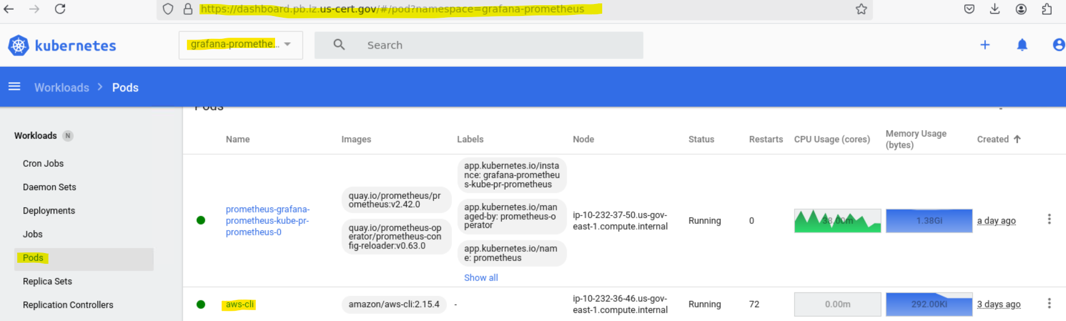

List of Prometheus Targets:
--------------------------------------
khaled.fouad ~/Documents/Repos/Scripts-Logs/Kubernetes-Grafana-Config ❯ kubectl exec -it aws-cli -n grafana-prometheus -- /bin/sh

Run this curl command to show the list of Prometheus targets, while filtering on the http links.

sh-4.2# curl -s http://grafana-prometheus-kube-pr-prometheus.grafana-prometheus:9090/api/v1/targets | grep -o '"scrapeUrl":"[^"]*"' | sed 's/"scrapeUrl":"//g' | sed 's/"//g'
http://10.232.32.122:9093/metrics
https://10.232.34.116:443/metrics
https://10.232.35.181:443/metrics
http://10.232.36.199:9153/metrics
http://10.232.37.133:9153/metrics
http://10.232.37.50:10249/metrics
http://10.232.32.80:10249/metrics
http://10.232.33.136:10249/metrics
http://10.232.33.200:10249/metrics
http://10.232.35.28:10249/metrics
sh-4.2#

Run this curl command to show the list of Prometheus targets.

sh-4.2# curl -v http://grafana-prometheus-kube-pr-prometheus.grafana-prometheus:9090/api/v1/targets
* Trying 172.20.55.49:9090...
* Connected to grafana-prometheus-kube-pr-prometheus.grafana-prometheus (172.20.55.49) port 9090
> GET /api/v1/targets HTTP/1.1
> Host: grafana-prometheus-kube-pr-prometheus.grafana-prometheus:9090
> User-Agent: curl/8.3.0
> Accept: */*
>
< HTTP/1.1 200 OK
< Content-Type: application/json
< Date: Tue, 20 May 2025 16:21:16 GMT
< Transfer-Encoding: chunked
<
{"status":"success","data":{"activeTargets":[{"discoveredLabels":{"__address__":"10.232.32.122:9093","__meta_kubernetes_endpoint_address_target_kind":"Pod","__meta_kubernetes_endpoint_address_target_name":"alertmanager-grafana-prometheus-kube-pr-alertmanager-0","__meta_kubernetes_endpoint_node_name":"ip-10-232-32-80.us-gov-east-1.compute.internal","__meta_kubernetes_endpoint_port_name":"http-web","__meta_kubernetes_endpoint_port_protocol":"TCP","__meta_kubernetes_endpoint_ready":"true","__meta_kubernetes_endpoints_label_app":"kube-prometheus-stack-alertmanager","__meta_kubernetes_endpoints_label_app_kubernetes_io_instance":"grafana-prometheus","__meta_kubernetes_endpoints_label_app_kubernetes_io_managed_by":"Helm","__meta_kubernetes_endpoints_label_app_kubernetes_io_part_of":"kube-prometheus-

sh-4.2# curl -v http://grafana-prometheus-kube-pr-prometheus.grafana-prometheus:9090/api/v1/label/__name__/values
* Trying 172.20.55.49:9090...
* Connected to grafana-prometheus-kube-pr-prometheus.grafana-prometheus (172.20.55.49) port 9090
> GET /api/v1/label/__name__/values HTTP/1.1
> Host: grafana-prometheus-kube-pr-prometheus.grafana-prometheus:9090
> User-Agent: curl/8.3.0
> Accept: */*
>
< HTTP/1.1 200 OK
< Content-Type: application/json
< Date: Tue, 20 May 2025 16:33:42 GMT
< Transfer-Encoding: chunked
<
{"status":"success","data":["ALERTS","ALERTS_FOR_STATE","aggregator_discovery_aggregation_count_total","aggregator_unavailable_apiservice","aggregator_unavailable_apiservice_total","alertmanager_alerts","alertmanager_alerts_invalid_total","alertmanager_alerts_received_total","alertmanager_build_info","alertmanager_cluster_enabled","alertmanager_config_hash","alertmanager_config_last_reload_success_timestamp_seconds","alertmanager_config_last_reload_successful","alertmanager_dispatcher_aggregation_groups","alertmanager_dispatcher_alert_processing_duration_seconds_count","alertmanager_dispatcher_alert_processing_duration_seconds_sum","alertmanager_http_concurrency_limit_exceeded_total","alertmanager_http_request_duration_seconds_bucket","alertmanager_http_request_duration_seconds_count","alertmanager_http_request_duration_seconds_sum","alertmanager_http_requests_in_flight","alertmanager_http_response_size_bytes_bucket","alertmanager_http_response_size_bytes_count","alertmanager_http_response_size_bytes_sum","alertmanager_integrations","alertmanager_marked_alerts","alertmanager_nflog_gc_duration_seconds_count","alertmanager_nflog_gc_duration_seconds_sum","alertmanager_nflog_gossip_messages_propagated_total","alertmanager_nflog_queries_total","alertmanager_nflog_query_duration_seconds_bucket","alertmanager_nflog_query_duration_seconds_count","alertmanager_nflog_query_duration_seconds_sum","alertmanager_nflog_query_errors_total","alertmanager_nflog_snapshot_duration_seconds_count","alertmanager_nflog_snapshot_duration_seconds_sum","alertmanager_nflog_snapshot_size_bytes","alertmanager_notification_latency_seconds_bucket","alertmanager_notification_latency_seconds_count","alertmanager_notification_latency_seconds_sum","alertmanager_notification_requests_failed_total","alertmanager_notification_requests_total","alertmanager_notifications_failed_total","alertmanager_notifications_total","alertmanager_receivers","alertmanager_silences","alertmanager_silences_gc_duration_seconds_count","alertmanager_silences_gc_duration_seconds_sum","alertmanager_silences_gossip_messages_propagated_total","alertmanager_silences_queries_total","alertmanager_silences_query_duration_seconds_bucket","alertmanager_silences_query_duration_seconds_count","alertmanager_silences_query_duration_seconds_sum","alertmanager_silences_query_errors_total","alertmanager_silences_snapshot_duration_seconds_count","alertmanager_silences_snapshot_duration_seconds_sum","alertmanager_silences_snapshot_size_bytes","apiextensions_apiserver_validation_ratcheting_seconds_bucket","apiextensions_apiserver_validation_ratcheting_seconds_count","apiextensions_apiserver_validation_ratcheting_seconds_sum","apiextensions_openapi_v2_regeneration_count","apiextensions_openapi_v3

Run this command to show the release name for grafana-prometheus.

khaled.fouad ~/Documents/Repos/Scripts-Logs/Kubernetes-Grafana-Config ❯ kubectl get prometheus -n grafana-prometheus -o yaml
apiVersion: v1
items:
- apiVersion: monitoring.coreos.com/v1
kind: Prometheus
metadata:
annotations:
meta.helm.sh/release-name: grafana-prometheus
meta.helm.sh/release-namespace: grafana-prometheus
creationTimestamp: "2023-04-27T20:46:33Z"
generation: 1
labels:
app: kube-prometheus-stack-prometheus
app.kubernetes.io/instance: grafana-prometheus
app.kubernetes.io/managed-by: Helm
app.kubernetes.io/part-of: kube-prometheus-stack
app.kubernetes.io/version: 45.21.0
chart: kube-prometheus-stack-45.21.0
heritage: Helm
release: grafana-prometheus
name: grafana-prometheus-kube-pr-prometheus
namespace: grafana-prometheus
resourceVersion: "493714815"
uid: 897c09f4-440a-462c-bb5a-99015565b672
spec:
alerting:
alertmanagers:
- apiVersion: v2
name: grafana-prometheus-kube-pr-alertmanager
namespace: grafana-prometheus
pathPrefix: /
port: http-web
enableAdminAPI: false
evaluationInterval: 30s
externalUrl: http://grafana-prometheus-kube-pr-prometheus.grafana-prometheus:9090
hostNetwork: false
image: quay.io/prometheus/prometheus:v2.42.0
listenLocal: false
logFormat: logfmt
logLevel: info
paused: false
podMonitorNamespaceSelector: {}
podMonitorSelector:
matchLabels:
release: grafana-prometheus
portName: http-web
probeNamespaceSelector: {}
probeSelector:
matchLabels:
release: grafana-prometheus
replicas: 1
retention: 10d
routePrefix: /
ruleNamespaceSelector: {}
ruleSelector:
matchLabels:
release: grafana-prometheus
scrapeInterval: 30s
securityContext:
fsGroup: 2000
runAsGroup: 2000
runAsNonRoot: true
runAsUser: 1000
serviceAccountName: grafana-prometheus-kube-pr-prometheus
serviceMonitorNamespaceSelector: {}
serviceMonitorSelector:
matchLabels:
release: grafana-prometheus
shards: 1
tsdb:
outOfOrderTimeWindow: 0s
version: v2.42.0
walCompression: true
status:
availableReplicas: 1
conditions:
- lastTransitionTime: "2025-05-14T00:37:56Z"
observedGeneration: 1
status: "True"
type: Available
- lastTransitionTime: "2025-03-28T03:13:32Z"
observedGeneration: 1
status: "True"
type: Reconciled
paused: false
replicas: 1
shardStatuses:
- availableReplicas: 1
replicas: 1
shardID: "0"
unavailableReplicas: 0
updatedReplicas: 1
unavailableReplicas: 0
updatedReplicas: 1
kind: List
metadata:
resourceVersion: ""

Deployed Service Monitors for Prometheus Targets:
-----------------------------------------------------------------------

Run this command to show the list of deployed service monitors for Prometheus targets.

khaled.fouad ~/Documents/Repos/Scripts-Logs/Kubernetes-Grafana-Config ❯ kubectl get servicemonitors.monitoring.coreos.com -A
NAMESPACE NAME AGE
grafana-prometheus cloudbees-monitor 7m30s
grafana-prometheus grafana-prometheus 2y24d
grafana-prometheus grafana-prometheus-kube-pr-alertmanager 2y24d
grafana-prometheus grafana-prometheus-kube-pr-apiserver 2y24d
grafana-prometheus grafana-prometheus-kube-pr-coredns 2y24d
grafana-prometheus grafana-prometheus-kube-pr-kube-controller-manager 2y24d
grafana-prometheus grafana-prometheus-kube-pr-kube-etcd 2y24d
grafana-prometheus grafana-prometheus-kube-pr-kube-proxy 2y24d
grafana-prometheus grafana-prometheus-kube-pr-kube-scheduler 2y24d
grafana-prometheus grafana-prometheus-kube-pr-kubelet 2y24d
grafana-prometheus grafana-prometheus-kube-pr-operator 2y24d
grafana-prometheus grafana-prometheus-kube-pr-prometheus 2y24d
grafana-prometheus grafana-prometheus-kube-state-metrics 2y24d
grafana-prometheus grafana-prometheus-prometheus-node-exporter 2y24d

khaled.fouad ~/Documents/Repos/Scripts-Logs/Kubernetes-Grafana-Config ❯ kubectl get servicemonitors.monitoring.coreos.com cloudbees-monitor -n grafana-prometheus -o yaml
apiVersion: monitoring.coreos.com/v1
kind: ServiceMonitor
metadata:
annotations:
kubectl.kubernetes.io/last-applied-configuration: |
{"apiVersion":"monitoring.coreos.com/v1","kind":"ServiceMonitor","metadata":{"annotations":{},"labels":{"release":"grafana-prometheus"},"name":"cloudbees-monitor","namespace":"grafana-prometheus"},"spec":{"endpoints":[{"interval":"30s","path":"/cjoc/prometheus","port":"http","scheme":"http"}],"namespaceSelector":{"matchNames":["cloudbees"]},"selector":{"matchLabels":{"app":"cloudbees"}}}}
creationTimestamp: "2025-05-20T20:47:50Z"
generation: 1
labels:
release: grafana-prometheus
name: cloudbees-monitor
namespace: grafana-prometheus
resourceVersion: "499814482"
uid: 800ca628-99d1-4b27-a0a4-50f67fe5a497
spec:
endpoints:
- interval: 30s
path: /cjoc/prometheus
port: http
scheme: http
namespaceSelector:
matchNames:
- cloudbees
selector:
matchLabels:
app: cloudbees

Prometheus Port Forwarding:
-----------------------------------------
khaled.fouad ~ ❯ kubectl get svc/prometheus-operated -n grafana-prometheus --show-labels
NAME TYPE CLUSTER-IP EXTERNAL-IP PORT(S) AGE LABELS
prometheus-operated ClusterIP None <none> 9090/TCP 2y26d operated-prometheus=true

We get the port number which is 9090 from above.

We forward port 9090 to port 9090, so localhost will access Prometheus on port 9090.

khaled.fouad ~/Documents/Repos/Scripts-Logs/Kubernetes-Grafana-Config ❯ kubectl port-forward svc/prometheus-operated 9090:9090 -n grafana-prometheus
Forwarding from 127.0.0.1:9090 -> 9090
Forwarding from [::1]:9090 -> 9090
Handling connection for 9090
Handling connection for 9090
Handling connection for 9090
Handling connection for 9090

Then, Access Prometheus through Firefox browser: http://localhost:9090

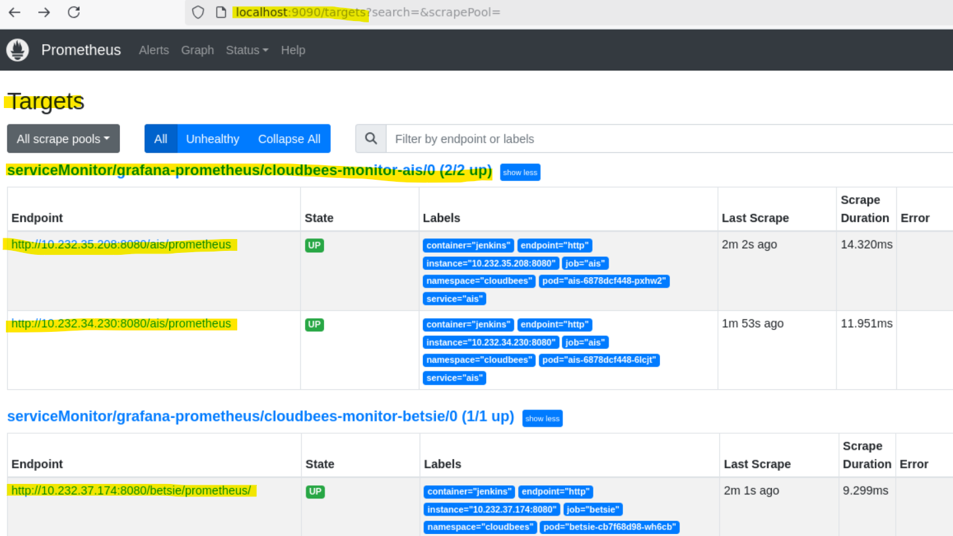

Cloudbees Port Forwarding:
-----------------------------------------
khaled.fouad ~ ❯ kubectl get svc cjoc -n cloudbees --show-labels
NAME TYPE CLUSTER-IP EXTERNAL-IP PORT(S) AGE LABELS
cjoc ClusterIP 172.20.130.131 <none> 80/TCP,50000/TCP 2y24d app.kubernetes.io/component=cjoc,app.kubernetes.io/instance=cloudbees-core,app.kubernetes.io/managed-by=Helm,app.kubernetes.io/name=cloudbees-core,helm.sh/chart=cloudbees-core-3.22283.0_4b0b554033da

We get the port number which is 80 from above.

Then, We forward port 80 to port 8080, so localhost will access Cloudbees Metrics on port 8080.

khaled.fouad ~ ❯ kubectl port-forward svc/cjoc 8080:80 -n cloudbees
Forwarding from 127.0.0.1:8080 -> 8080
Forwarding from [::1]:8080 -> 8080
Handling connection for 8080

Then, Access Cloudbees Metrics through Firefox browser: http://localhost:8080

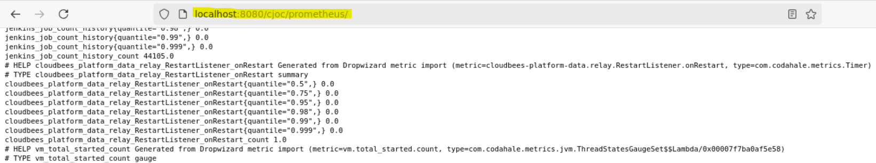

khaled.fouad ~ ❯ kubectl get svc -n cloudbees --show-labels
NAME TYPE CLUSTER-IP EXTERNAL-IP PORT(S) AGE LABELS
ais ClusterIP 172.20.211.116 <none> 80/TCP,50014/TCP 251d com.cloudbees.cje.tenant=ais,com.cloudbees.cje.type=master,com.cloudbees.pse.tenant=ais,com.cloudbees.pse.type=master,tenant=ais,type=master
betsie ClusterIP 172.20.73.236 <none> 80/TCP,50019/TCP 54d com.cloudbees.cje.tenant=betsie,com.cloudbees.cje.type=master,com.cloudbees.pse.tenant=betsie,com.cloudbees.pse.type=master,tenant=betsie,type=master
cart-az ClusterIP 172.20.149.228 <none> 80/TCP,50015/TCP 136d com.cloudbees.cje.tenant=cart-az,com.cloudbees.cje.type=master,com.cloudbees.pse.tenant=cart-az,com.cloudbees.pse.type=master,tenant=cart-az,type=master
cart-co ClusterIP 172.20.13.7 <none> 80/TCP,50006/TCP 247d com.cloudbees.cje.tenant=cart-co,com.cloudbees.cje.type=master,com.cloudbees.pse.tenant=cart-co,com.cloudbees.pse.type=master,tenant=cart-co,type=master
cart-iot ClusterIP 172.20.199.134 <none> 80/TCP,50017/TCP 159d com.cloudbees.cje.tenant=cart-iot,com.cloudbees.cje.type=master,com.cloudbees.pse.tenant=cart-iot,com.cloudbees.pse.type=master,tenant=cart-iot,type=master
cjoc ClusterIP 172.20.130.131 <none> 80/TCP,50000/TCP 2y24d app.kubernetes.io/component=cjoc,app.kubernetes.io/instance=cloudbees-core,app.kubernetes.io/managed-by=Helm,app.kubernetes.io/name=cloudbees-core,helm.sh/chart=cloudbees-core-3.22283.0_4b0b554033da

This is listing all cloudbees services.

khaled.fouad ~ ❯ kubectl get svc -n cloudbees
NAME TYPE CLUSTER-IP EXTERNAL-IP PORT(S) AGE
ais ClusterIP 172.20.211.116 <none> 80/TCP,50014/TCP 251d
betsie ClusterIP 172.20.73.236 <none> 80/TCP,50019/TCP 54d
cart-az ClusterIP 172.20.149.228 <none> 80/TCP,50015/TCP 136d
cart-co ClusterIP 172.20.13.7 <none> 80/TCP,50006/TCP 247d
cart-iot ClusterIP 172.20.199.134 <none> 80/TCP,50017/TCP 159d
cjoc ClusterIP 172.20.130.131 <none> 80/TCP,50000/TCP 2y24d
claw ClusterIP 172.20.15.56 <none> 80/TCP,50020/TCP 50d
cloudbees ClusterIP 172.20.2.9 <none> 80/TCP 25m
cyhy ClusterIP 172.20.22.198 <none> 80/TCP,50008/TCP 136d
datart ClusterIP 172.20.223.160 <none> 80/TCP,50009/TCP 249d
datascience ClusterIP 172.20.62.239 <none> 80/TCP,50004/TCP 249d
infosec ClusterIP 172.20.49.96 <none> 80/TCP,50007/TCP 249d
ipaart ClusterIP 172.20.197.16 <none> 80/TCP,50016/TCP 194d
landingzone ClusterIP 172.20.42.90 <none> 80/TCP,50005/TCP 249d
malware ClusterIP 172.20.68.109 <none> 80/TCP,50010/TCP 347d
maple-gcp ClusterIP 172.20.38.3 <none> 80/TCP,50018/TCP 70d
rsaa ClusterIP 172.20.229.31 <none> 80/TCP,50013/TCP 249d
sailpoint ClusterIP 172.20.4.213 <none> 80/TCP,50012/TCP 288d
vince ClusterIP 172.20.189.233 <none> 80/TCP,50011/TCP 369d
yellowdog ClusterIP 172.20.38.231 <none> 80/TCP,50003/TCP 347d

Deploy cloudbees-service-monitor-cjoc:
-------------------------------------------------------
khaled.fouad ~ ❯ kubectl get svc cjoc -n cloudbees --show-labels
NAME TYPE CLUSTER-IP EXTERNAL-IP PORT(S) AGE LABELS
cjoc ClusterIP 172.20.130.131 <none> 80/TCP,50000/TCP 2y24d app.kubernetes.io/component=cjoc,app.kubernetes.io/instance=cloudbees-core,app.kubernetes.io/managed-by=Helm,app.kubernetes.io/name=cloudbees-core,helm.sh/chart=cloudbees-core-3.22283.0_4b0b554033da

Notice that the matchLabels section is referencing the above attributes from the CJOC service.
Also, notice the path: cjoc/prometheus

khaled.fouad ~ ❯ kubectl apply -f Cloudbees-Service-Monitor-CJOC.yaml

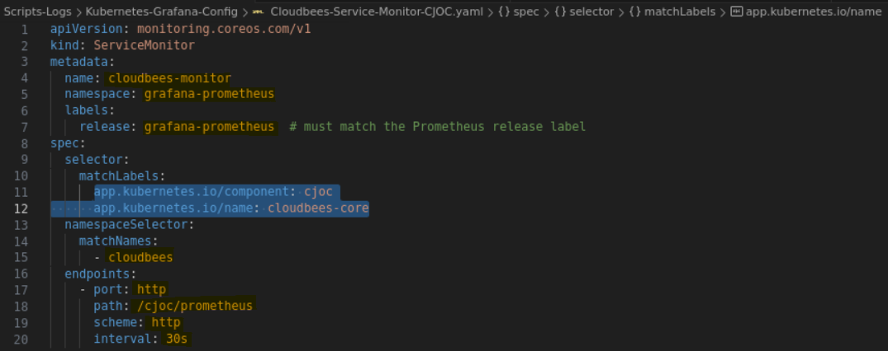

Deploy cloudbees-service-monitor-ais:
-----------------------------------------------------
khaled.fouad ~ ❯ kubectl get svc ais -n cloudbees --show-labels
NAME TYPE CLUSTER-IP EXTERNAL-IP PORT(S) AGE LABELS
ais ClusterIP 172.20.211.116 <none> 80/TCP,50014/TCP 254d com.cloudbees.cje.tenant=ais,com.cloudbees.cje.type=master,com.cloudbees.pse.tenant=ais,com.cloudbees.pse.type=master,tenant=ais,type=master

Notice that the matchLabels section is referencing the above attributes from the AIS service.
Also, notice the path: ais/prometheus

khaled.fouad ~ ❯ kubectl apply -f Cloudbees-Service-Monitor-AIS.yaml

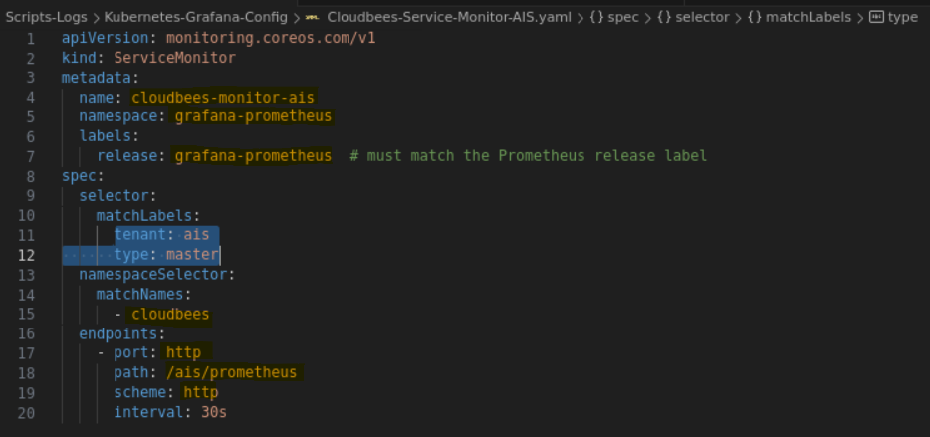

All Cloudbees Targets for All Controllers now shows up:
----------------------------------------------------------------------------

Exec into the aws-cli pod in order to do the curl commands

khaled.fouad ~ ❯ kubectl exec -it aws-cli -n grafana-prometheus -- /bin/sh

sh-4.2# curl -s http://grafana-prometheus-kube-pr-prometheus.grafana-prometheus:9090/api/v1/targets | grep -o '"scrapeUrl":"[^"]*"' | sed 's/"scrapeUrl":"//g' | sed 's/"//g'
http://10.232.32.74:8080/ais/prometheus
http://10.232.33.234:8080/ais/prometheus
http://10.232.36.77:8080/betsie/prometheus/
http://10.232.35.96:8080/cart-az/prometheus
http://10.232.35.153:8080/cart-co/prometheus/
http://10.232.33.191:8080/cart-iot/prometheus/
http://10.232.32.43:8080/claw/prometheus/
http://10.232.32.73:8080/cyhy/prometheus/
http://10.232.37.168:8080/datart/prometheus/
http://10.232.34.190:8080/datascience/prometheus/
http://10.232.33.32:8080/infosec/prometheus/
http://10.232.34.206:8080/ipaart/prometheus/
http://10.232.34.228:8080/landingzone/prometheus/
http://10.232.37.212:8080/malware/prometheus/
http://10.232.35.45:8080/maple-gcp/prometheus/
http://10.232.35.152:8080/rsaa/prometheus/
http://10.232.36.137:8080/sailpoint/prometheus/
http://10.232.36.248:8080/vince/prometheus/
http://10.232.37.36:8080/yellowdog/prometheus/
http://10.232.37.145:8080/cjoc/prometheus
http://10.232.32.122:9093/metrics
https://10.232.34.172:443/metrics

All Cloudbees Service Monitors for All Controllers now shows up:
-----------------------------------------------------------------------------------------

khaled.fouad ~ ❯ kubectl get servicemonitors.monitoring.coreos.com -A
NAMESPACE NAME AGE
grafana-prometheus cloudbees-monitor 2d19h
grafana-prometheus cloudbees-monitor-ais 46h
grafana-prometheus cloudbees-monitor-betsie 46h
grafana-prometheus cloudbees-monitor-cart-az 46h
grafana-prometheus cloudbees-monitor-cart-co 46h
grafana-prometheus cloudbees-monitor-cart-iot 46h
grafana-prometheus cloudbees-monitor-claw 46h
grafana-prometheus cloudbees-monitor-cyhy 46h
grafana-prometheus cloudbees-monitor-datart 46h
grafana-prometheus cloudbees-monitor-datascience 46h
grafana-prometheus cloudbees-monitor-infosec 46h
grafana-prometheus cloudbees-monitor-ipaart 46h
grafana-prometheus cloudbees-monitor-landingzone 46h
grafana-prometheus cloudbees-monitor-malware 46h
grafana-prometheus cloudbees-monitor-maple-gcp 46h
grafana-prometheus cloudbees-monitor-rsaa 46h
grafana-prometheus cloudbees-monitor-sailpoint 46h
grafana-prometheus cloudbees-monitor-vince 46h
grafana-prometheus cloudbees-monitor-yellowdog 46h
grafana-prometheus grafana-prometheus 2y26d
grafana-prometheus grafana-prometheus-kube-pr-alertmanager 2y26d
grafana-prometheus grafana-prometheus-kube-pr-apiserver 2y26d
grafana-prometheus grafana-prometheus-kube-pr-coredns 2y26d
grafana-prometheus grafana-prometheus-kube-pr-kube-controller-manager 2y26d
grafana-prometheus grafana-prometheus-kube-pr-kube-etcd 2y26d
grafana-prometheus grafana-prometheus-kube-pr-kube-proxy 2y26d
grafana-prometheus grafana-prometheus-kube-pr-kube-scheduler 2y26d
grafana-prometheus grafana-prometheus-kube-pr-kubelet 2y26d
grafana-prometheus grafana-prometheus-kube-pr-operator 2y26d
grafana-prometheus grafana-prometheus-kube-pr-prometheus 2y26d
grafana-prometheus grafana-prometheus-kube-state-metrics 2y26d
grafana-prometheus grafana-prometheus-prometheus-node-exporter 2y26d
grafana-prometheus twistlock-monitor 28h
khaled.fouad ~ ❯

Production EKS Cluster:
----------------------------------
Namespace: grafana-prometheus

Custom Resource Definitions --> Service Monitor

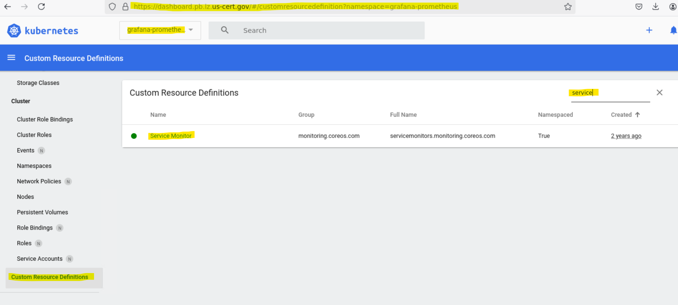

After Clicking on Service Monitor Above, You will see the list of all the deployed service monitors for all Cloudbees Controllers.

